**CIS-350  
Infrastructure Technologies**

**Lab 1 Report – Fall 2019**

**Student Name**: Mohammed Al Madhi

**Due Date: 10/28/2019 @11:00AM**

**You must use this template to hand in Lab1 Report.**

1. Insert the *Lab1_Tree* file from p. 25 of the Lab1 instructions into the space provided or use the *Alt-PrtScr* keys to capture the full screen output (full window) from command *TYPE Lab1_Tree* on p. 25 and paste that window here.

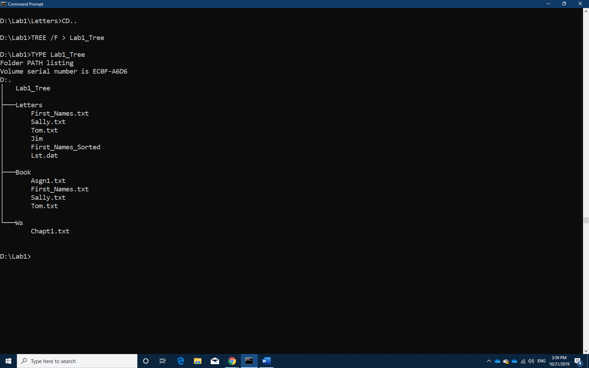

1. Below you have the following directory structure. At the top there is the root directory denoted by a backslash "\". *CLASSES*, *DOS*, *WINDOWS*, *BOOK*, *FINANCE*, etc. are the names of subdirectories residing under the root directory; *CONFIG.SYS* is the name of a file residing in the root directory, and *chkdsk.exe*, *CHAPTER1.DOC*, *Q.EXE*, etc. are the names of the files stored in the subdirectories. The system prompt displays"*C:****\****>*" which means that the current/default drive is *C* and the current/default directory is the root directory "**\**". The root directory "**\**" is just the origin for other directories/subdirectories.

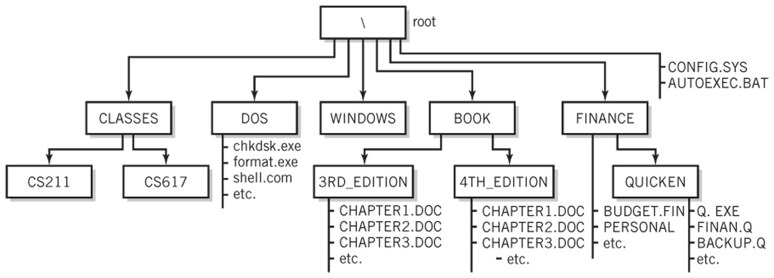

All questions (a) through (j) are based on the above directory diagram. For questions (a) through (f) assume the prompt "*C:* *>*" is displayed.

1. Write a command to copy file *CONFIG.SYS* to directory *DOS*. The copied file should have the same name as the original file, i.e., *CONFIG.SYS*.

* COPY CONFIG.SYS \DOS

1. Write a command to copy a file *CONFIG.SYS* to directory *QUICKEN*. The copied file should have new name *CONFIG1.SYS*.

* COPY CONFIG \QUICKEN\CONFIG1.SYS

1. Write a single command to copy all files whose names start with letter *C* from directory *4TH_EDITION* to directory *FINANCE*.

COPY BOOK\4TH_EDITION\C* \FINANCE

1. Write a single command to erase from directory *4TH_EDITION* all files whose names start with letter *C*.

ERASE BOOK\4TH_EDITION\C*

1. How many files would be erased by the command from p. (d) above?

* All Files whose name start with letter C. in the root picture above it’s showing there might be more than three CHAPTERS in the 4TH Edition since I see the Word etc included there.

1. Assume that *AUTOEXEC.BAT* is a large file. What command would you use to display the contents of the file one screen at a time (to prevent the output from scrolling off the screen)?

* TYPE AUTOEXEC.BAT /P

1. Look at the diagram. Assume that prompt "*C:\FINANCE\QUICKEN>*" is displayed, meaning that the current/default drive is *C* and the current/default directory is *\FINANCE\QUICKEN*. Write two separate *SORT* commands. Each of the two commands would accept input from file *BACKUP.Q*. However, the first command would route the output to file *BACKUP1.Q*, and the second one would append the output to file *BACKUP2.Q*.

* SORT < BACKUP.Q > BACKUP1.Q
* SORT < BACKUP.Q >> BACKUP2.Q

1. Look at the diagram. Assume that prompt "*C:\FINANCE\QUICKEN>*" is displayed. Write the command which would change the current directory to *FINANCE*.

* CD FINANCE

1. Look at the diagram. Assume that prompt "*C:\FINANCE>*" is displayed. In the space provided, sketch the directory structure with the subdirectory and file names which would command *TREE* /F generate.

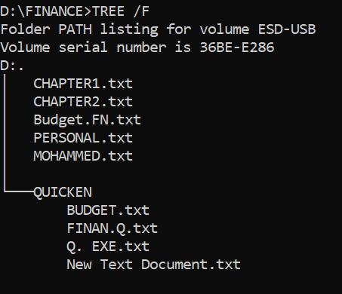

I have made my own root in my USB and tested what it would look like, above shows the files that are in ROOT Finance which includes CHAPTER 1 to MOHAMMED and below that is what inside QUICKEN FOLDER

1. Now assume that the "C:\ " prompt is displayed. Describe what a command

*DIR | SORT > DirList* would do.

When I tried this in my computer, it sorted the list of Directory and made a file named “DirList” when I opened it as txt file with notepad it showed the list of my C: files

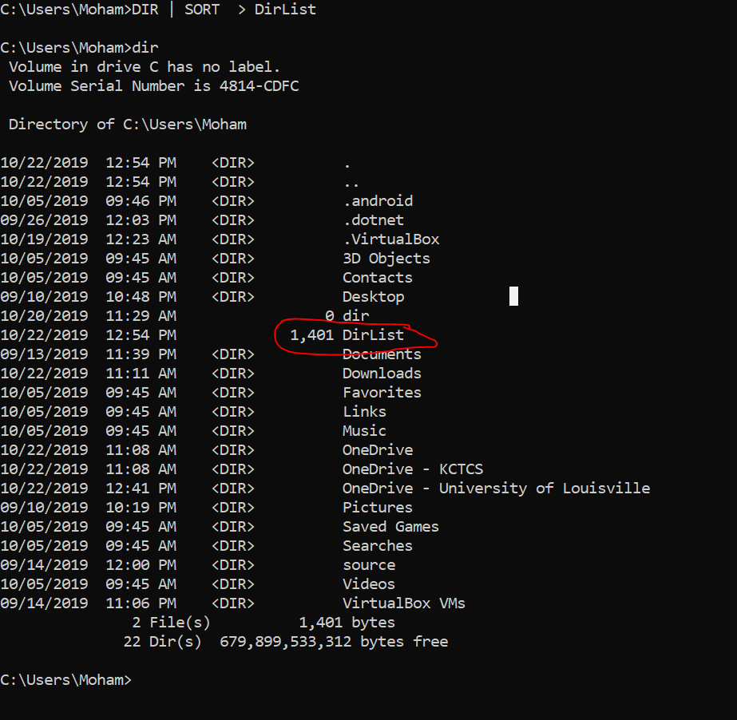

According to your lecture Lab1 Notes that I have read

“The output of the DIR command is sent as input to the SORT filter. The list of files is sorted in a temporary file and sent to file ~~Lst.dat~~(was changed here to “DirList”. If the ~~Lst.dat~~(DirList) file does not exist it will be created; if it exists it will be overwritten.”